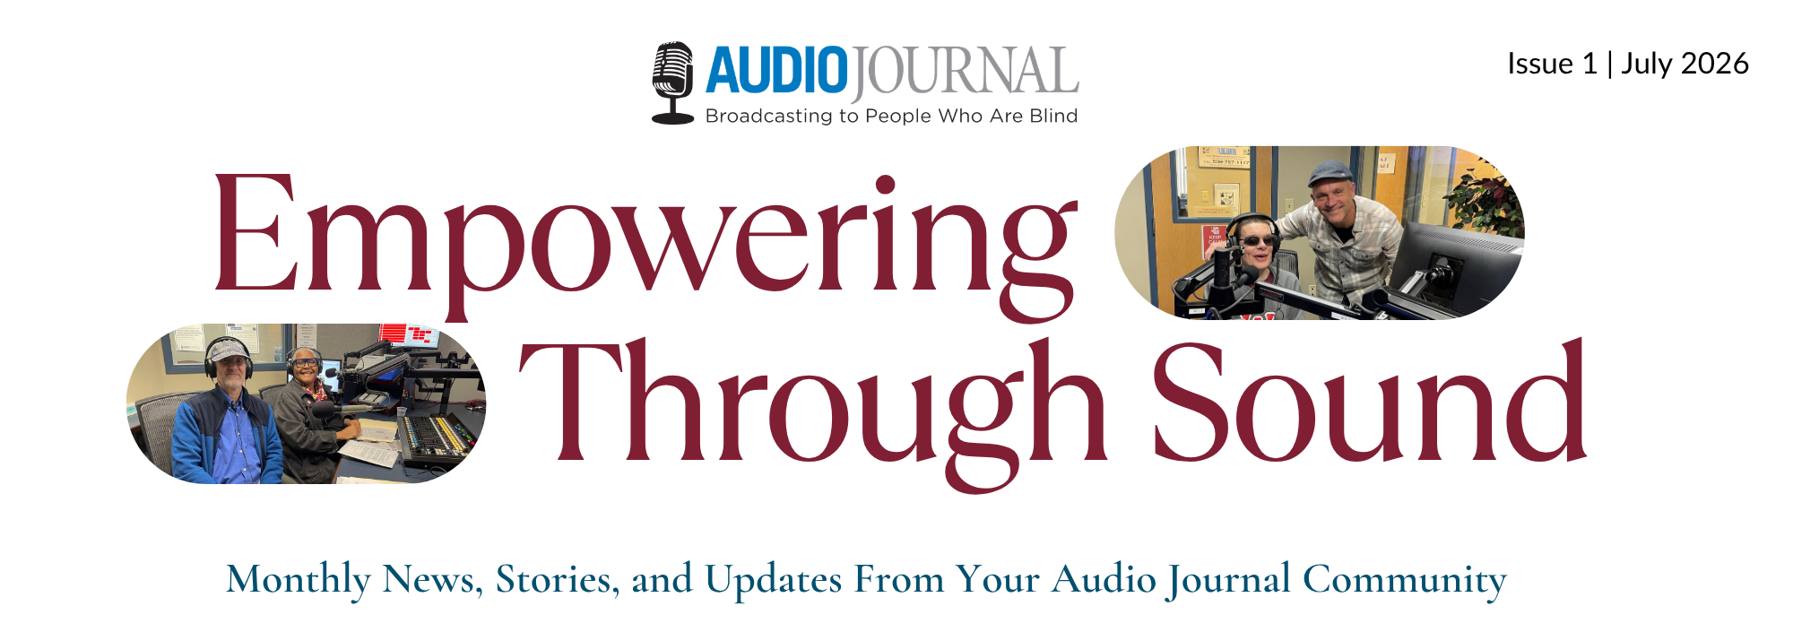
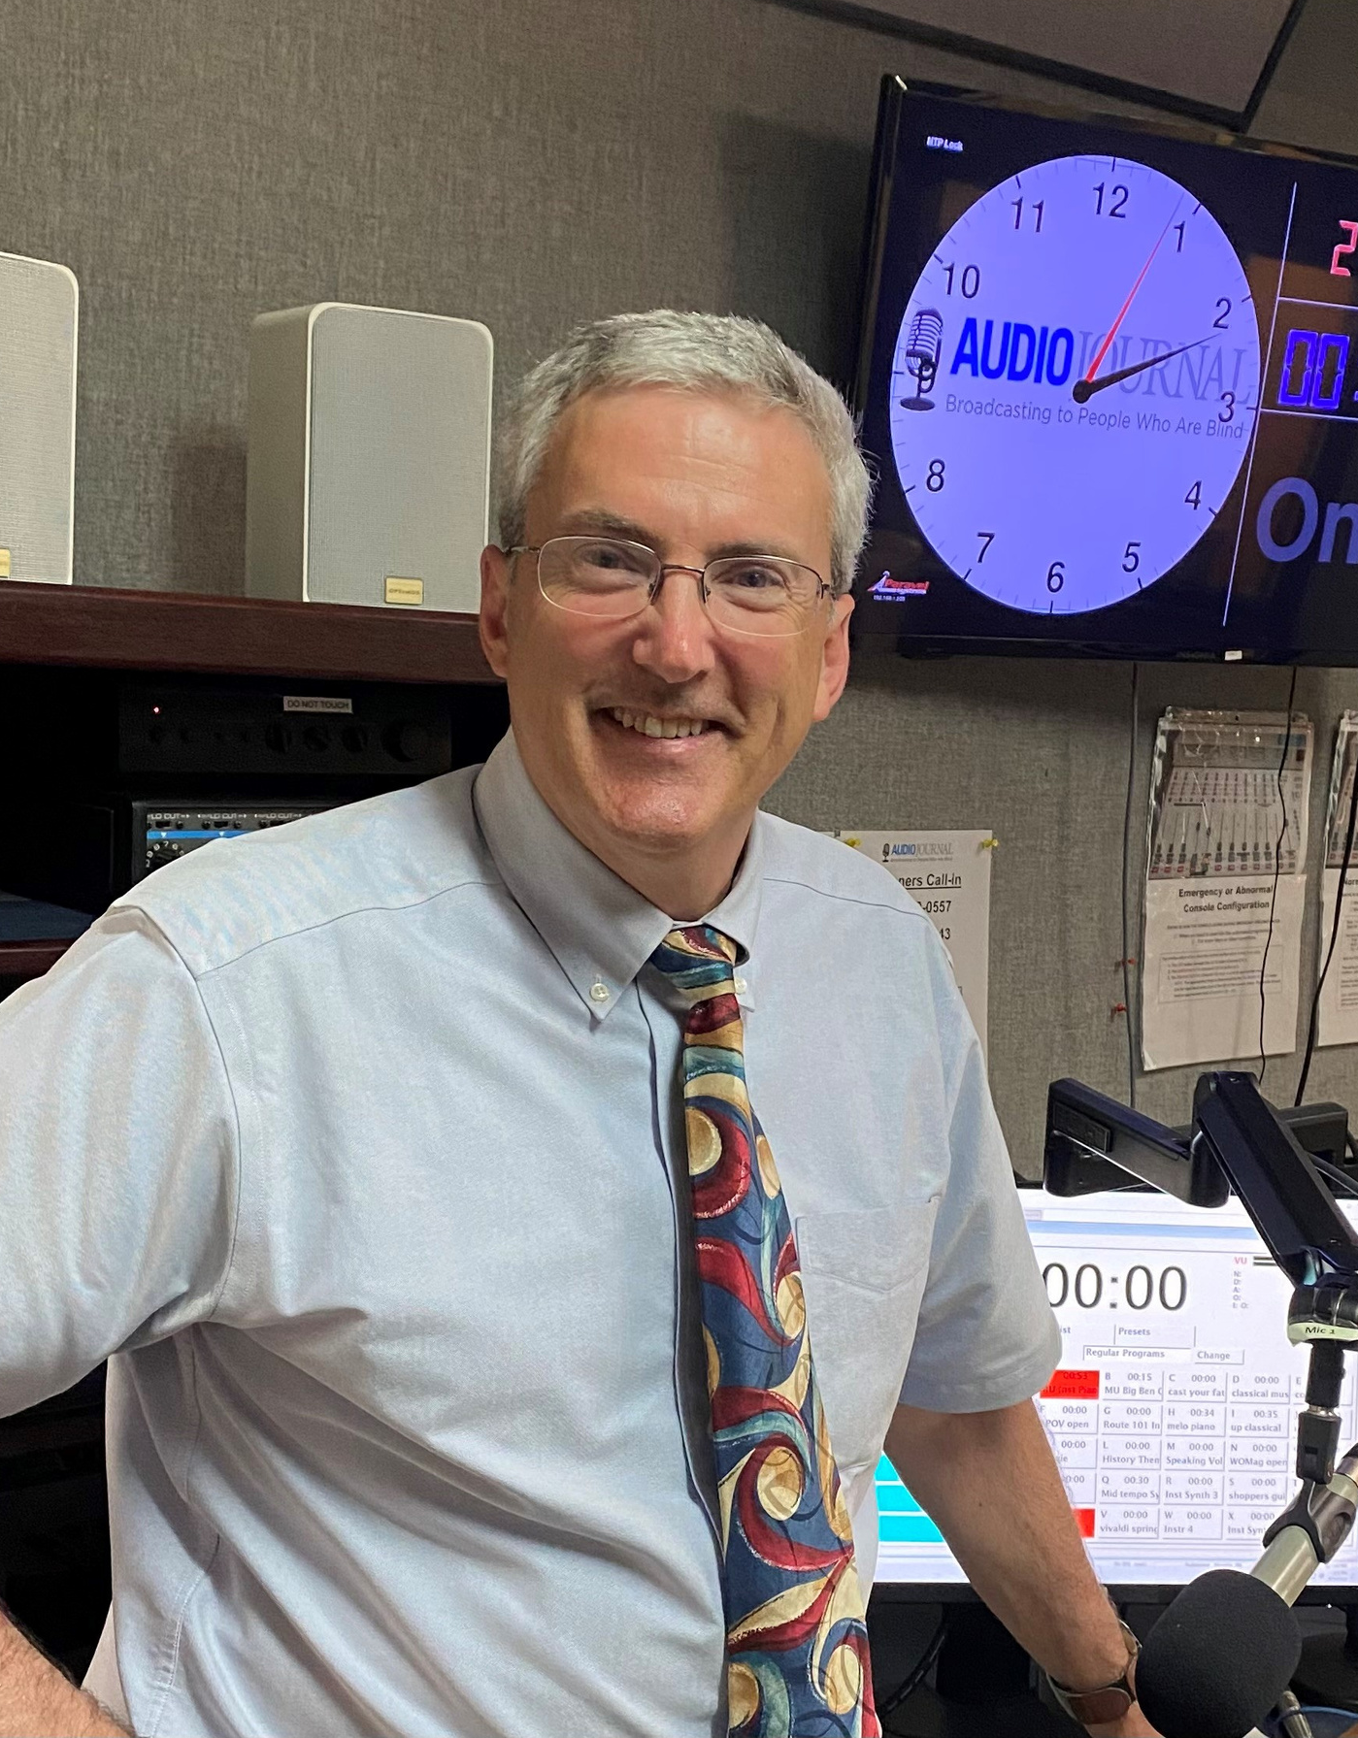 | Welcome!  A message from our Executive Director  Welcome to Audio Journal’s first newsletter of the 26-27 fiscal year!  Throughout the year, we will be sharing news, updates, and stories from the studio and all of you, our Audio Journal community.  If you have updates you’d like to share, please don’t hesitate to reach out to me at Harry@audiojournal.org.  Thanks for being here,  Harry Duchesne, Executive Director
Annual Appreciation Event
September 20th at Cyprian Keys
On September 20th at Cyprian Keyes in Boylston, we are recognizing and honoring all of our Supporters and Volunteers at our Annual Appreciation Event.  This year, we will be treating you to a concert with The Clements Brothers, the usual delicious hors d’oeuvres, appetizers and cash bar along with our traditional award ceremony.  Join us on Sunday, September 20th, from 1:00 - 3:00P at Cyprian Golf Club in Boylston MA.  Learn more at audiojournal.org/appreciation2026. | 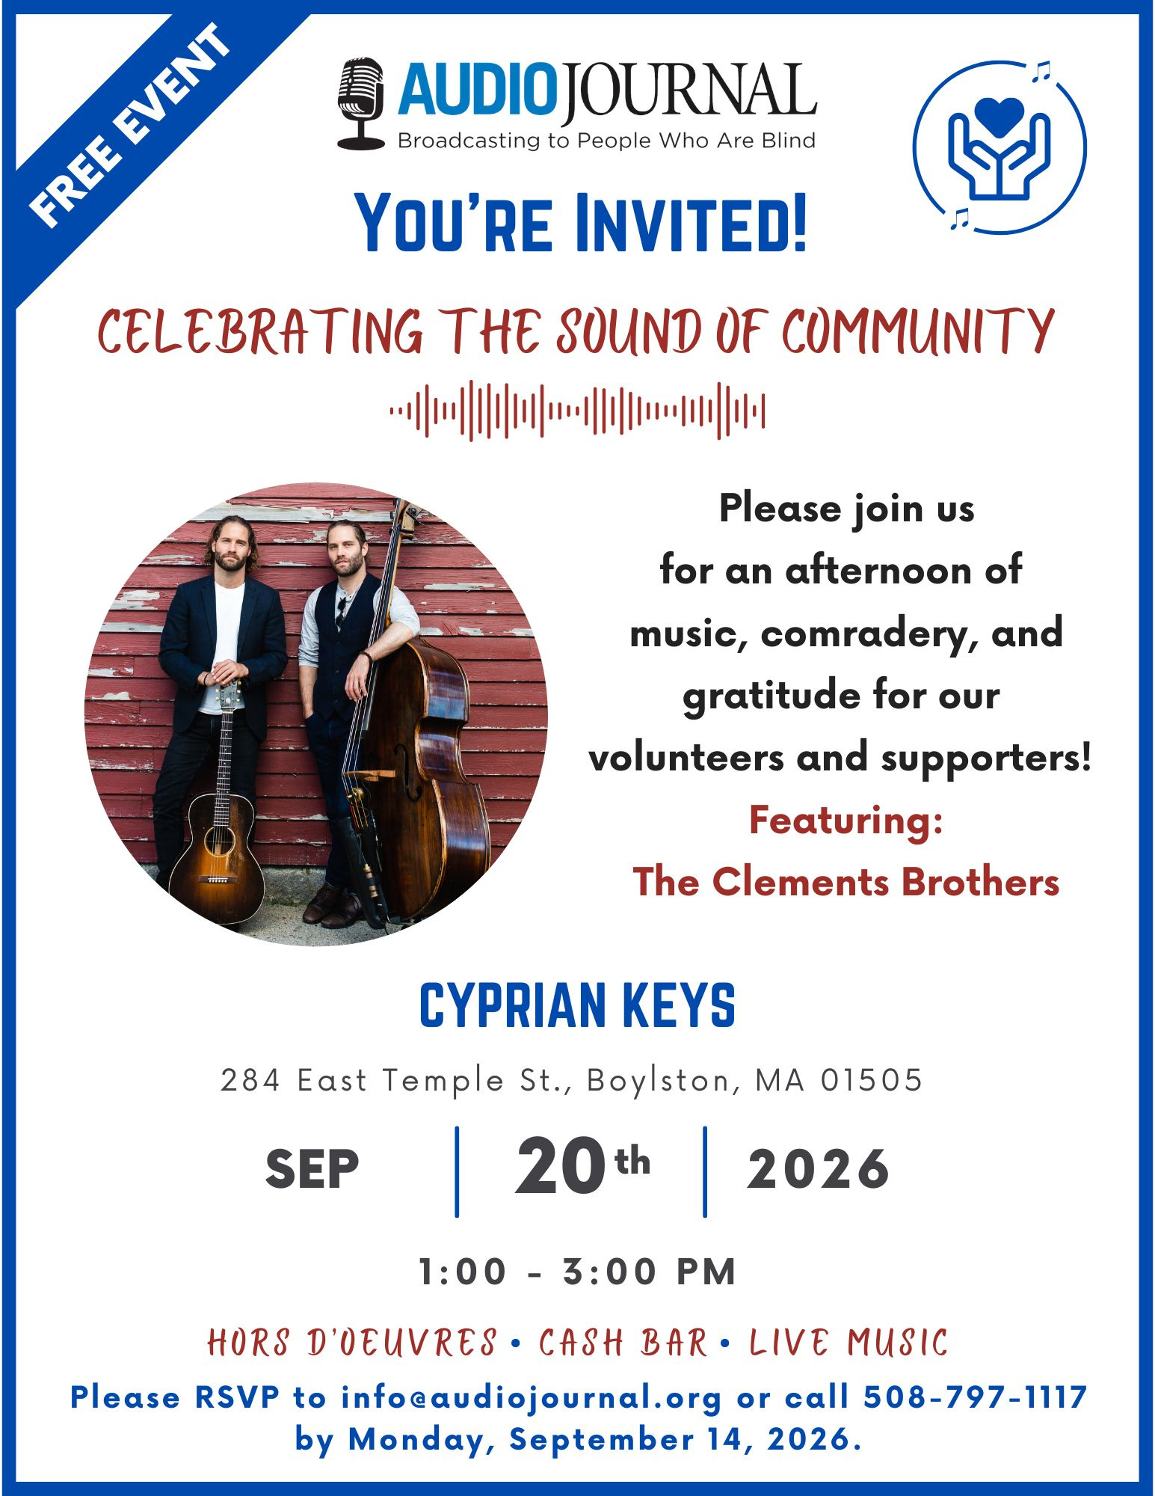
Have you heard the good news?!
As of June 1st, 2026, all of Audio Journal’s shows are now on 4 Podcast Platforms: Spotify, Apple Podcast, Amazon Music and PodBean! Just download one of these apps and start enjoying any or all of our quality News & Specialty Programs on a podcast app! When looking for a show, each title begins with AJ (i.e., AJ Telegram and Gazette or AJ Speaking Volumes).
 | 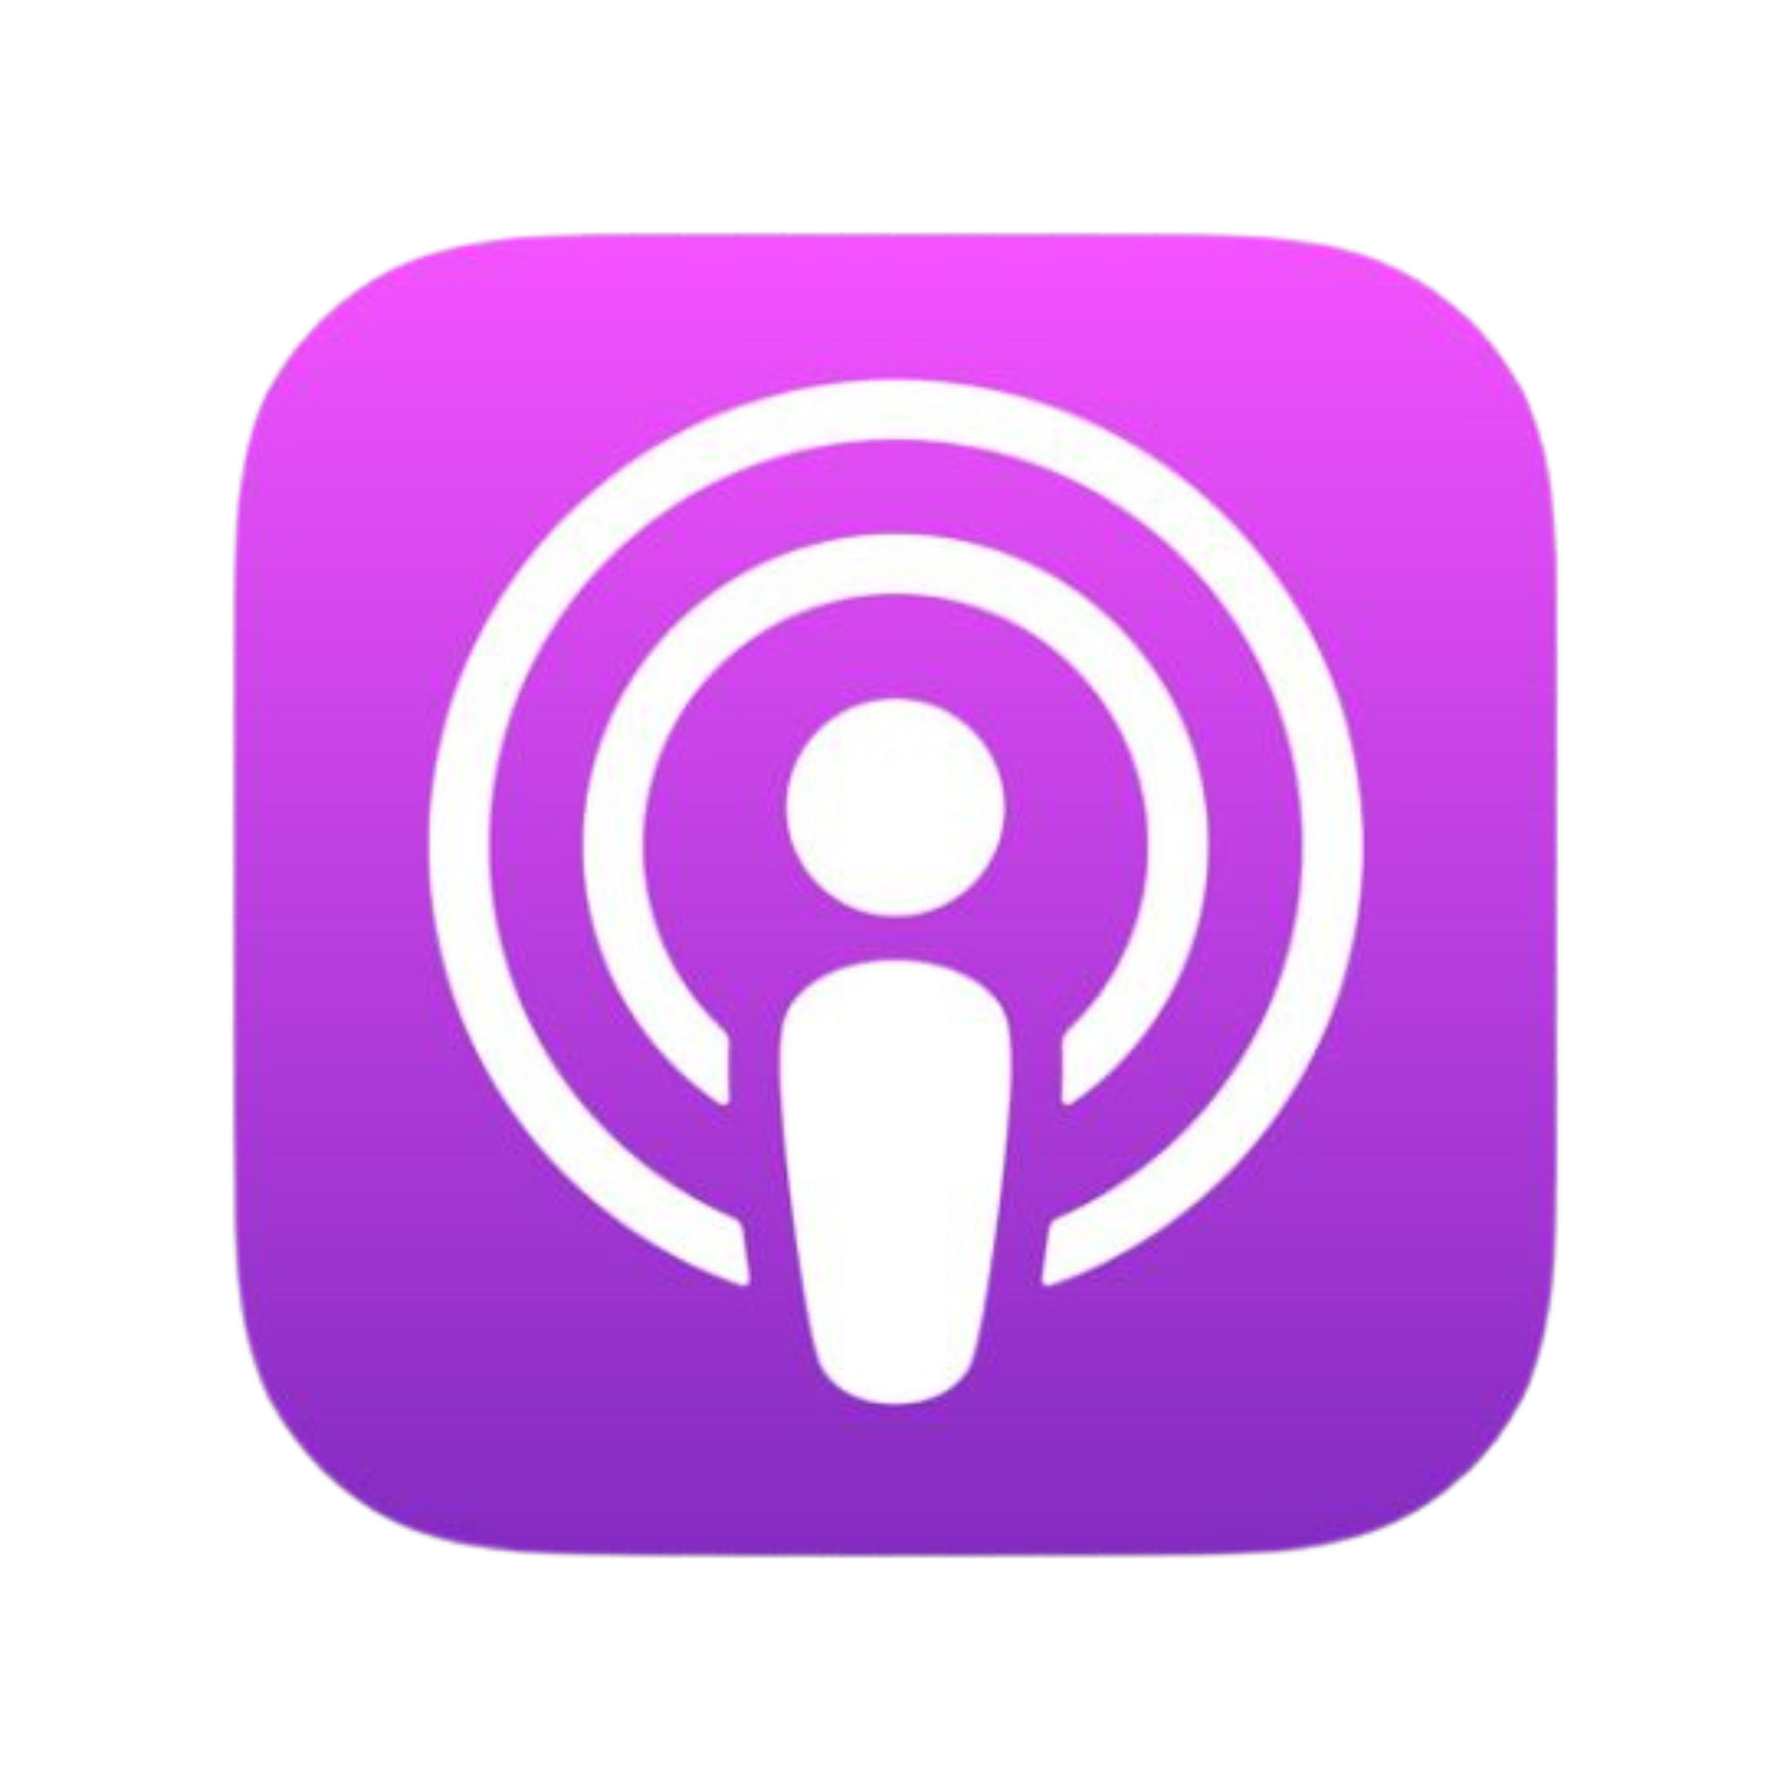 |  | 
Welcome to the team, Lavender!
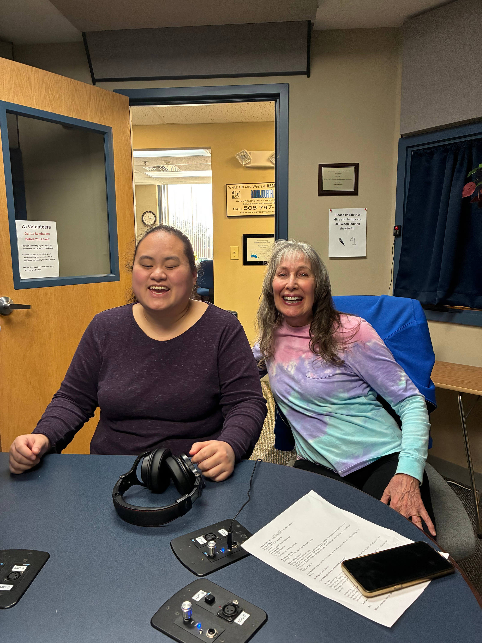 | Please help us celebrate our newest member of the AJ staff, Ms. Lavender Darcangelo! Lavender works just one day a week, but helps us with both creating shows, public service announcements and editing pre-recorded shows. Check out her shows: Young at Heart, Beyond the Pages, and More than Meets the Eye (coming soon on Podcast).

Volunteers Needed!
Audio Journal is always on the lookout for volunteers – especially with the following programs:
- Live Studio Readers for the “Boston Globe”
- Live or pre-recorded readers for our poetry show: “Poet’s Corner”
- Live Reader for our Senior Program: “An Older Voice”
- Pre-recorded readers for our Spanish News Show: “Vocero”
- Planners for our 40th Anniversary Fundraising Event – coming October, 2027!
For more information, please email us at info@audiojournal.org or call our office at 508-797-1117

