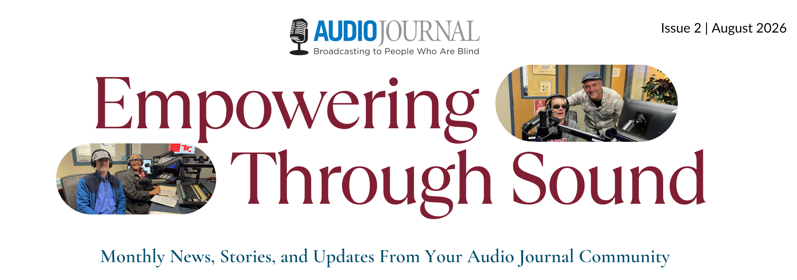

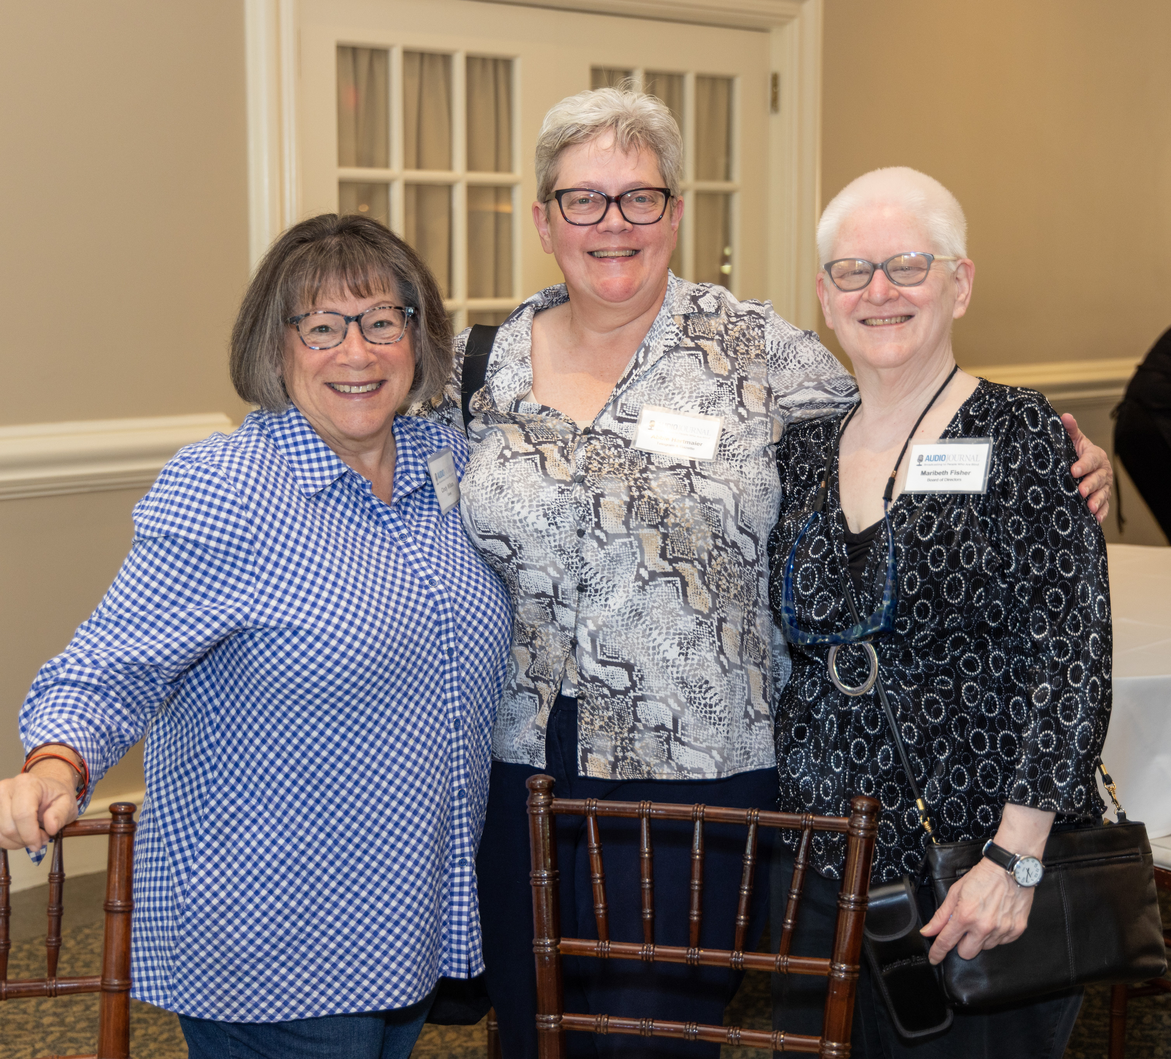
Don’t Miss Our Annual Volunteer & Supporter Recognition Day
September 20th at Cyprian Keys Golf Club, 284 E. Temple St., Boylston, MA
Our annual Volunteer and Supporter Recognition Event is coming up on September 20th, and we would love to see you there!  The event, being held from 1:00 - 3:00pm at Cyprian Keys Golf Club, will include delicious hors d’oeuvres, appetizers and a cash bar along with our traditional awards ceremony. This year will also feature live music from The Clements Brothers.  If you haven’t yet registered, please be sure to do so. We can’t wait to spend an afternoon showing our gratitude to all of our Audio Journal Volunteers and Supporters! | 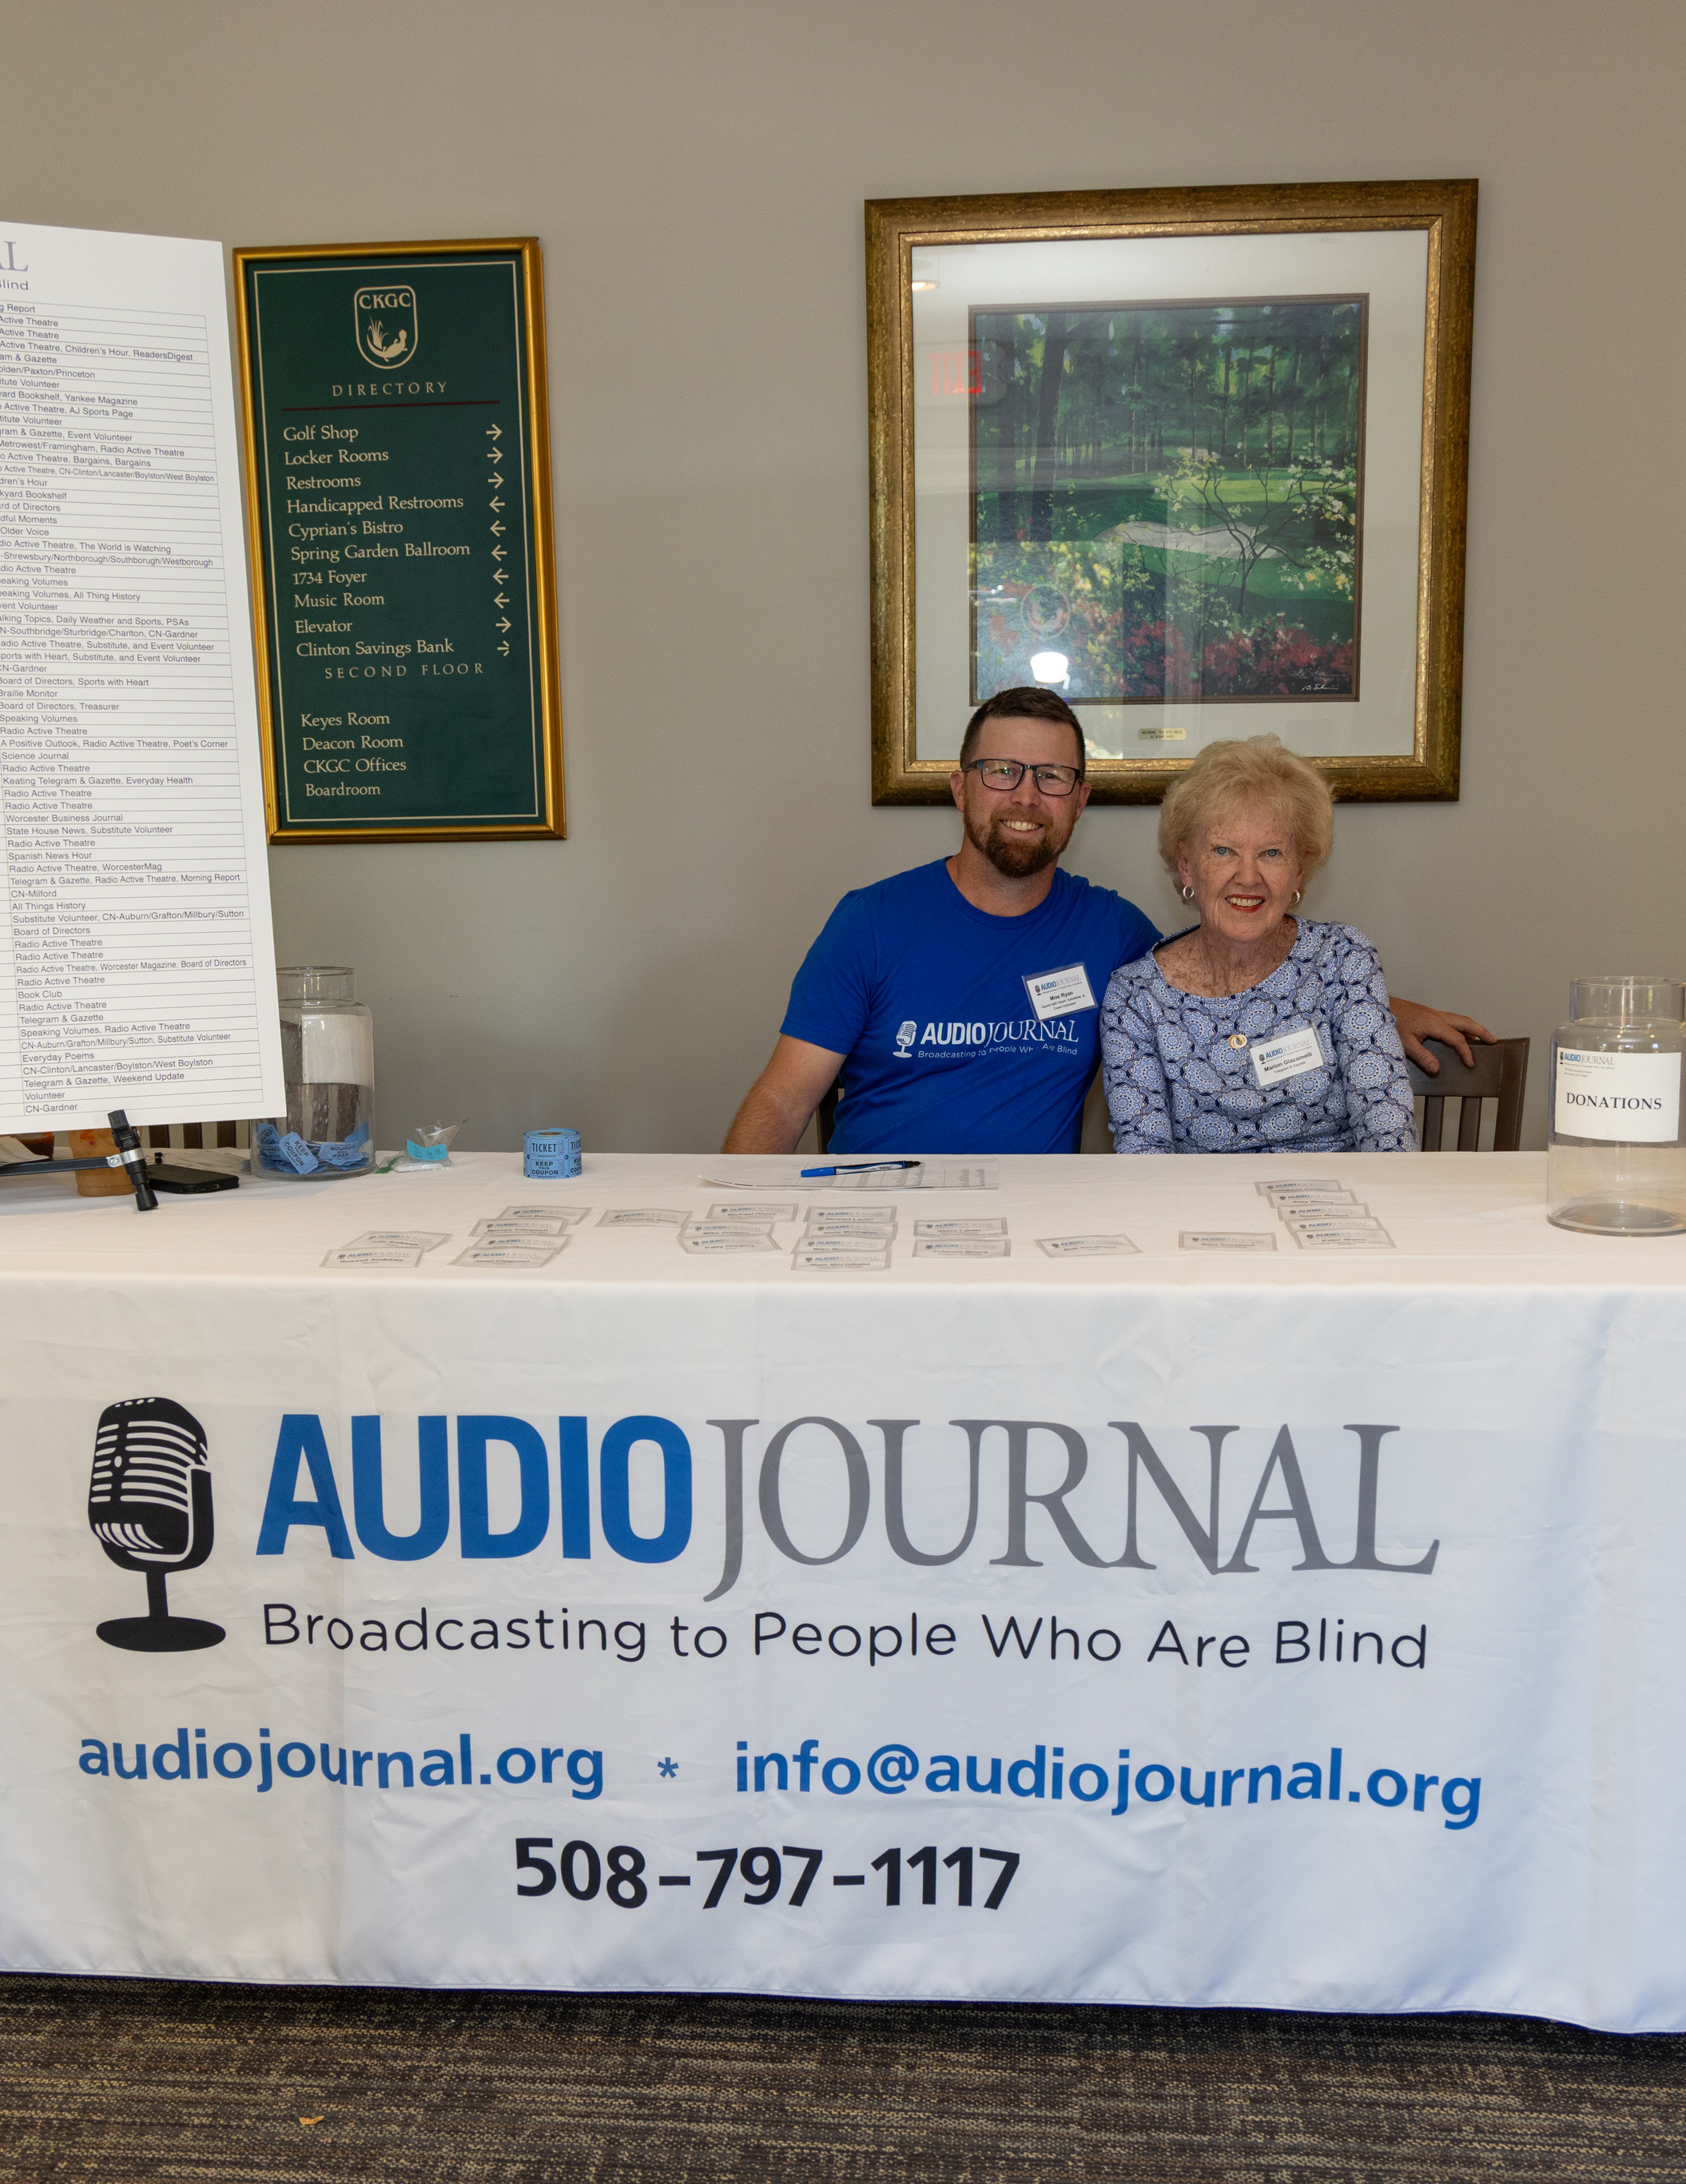
Sign Up | Learn More

Volunteer Spotlight: Ava Sardinha
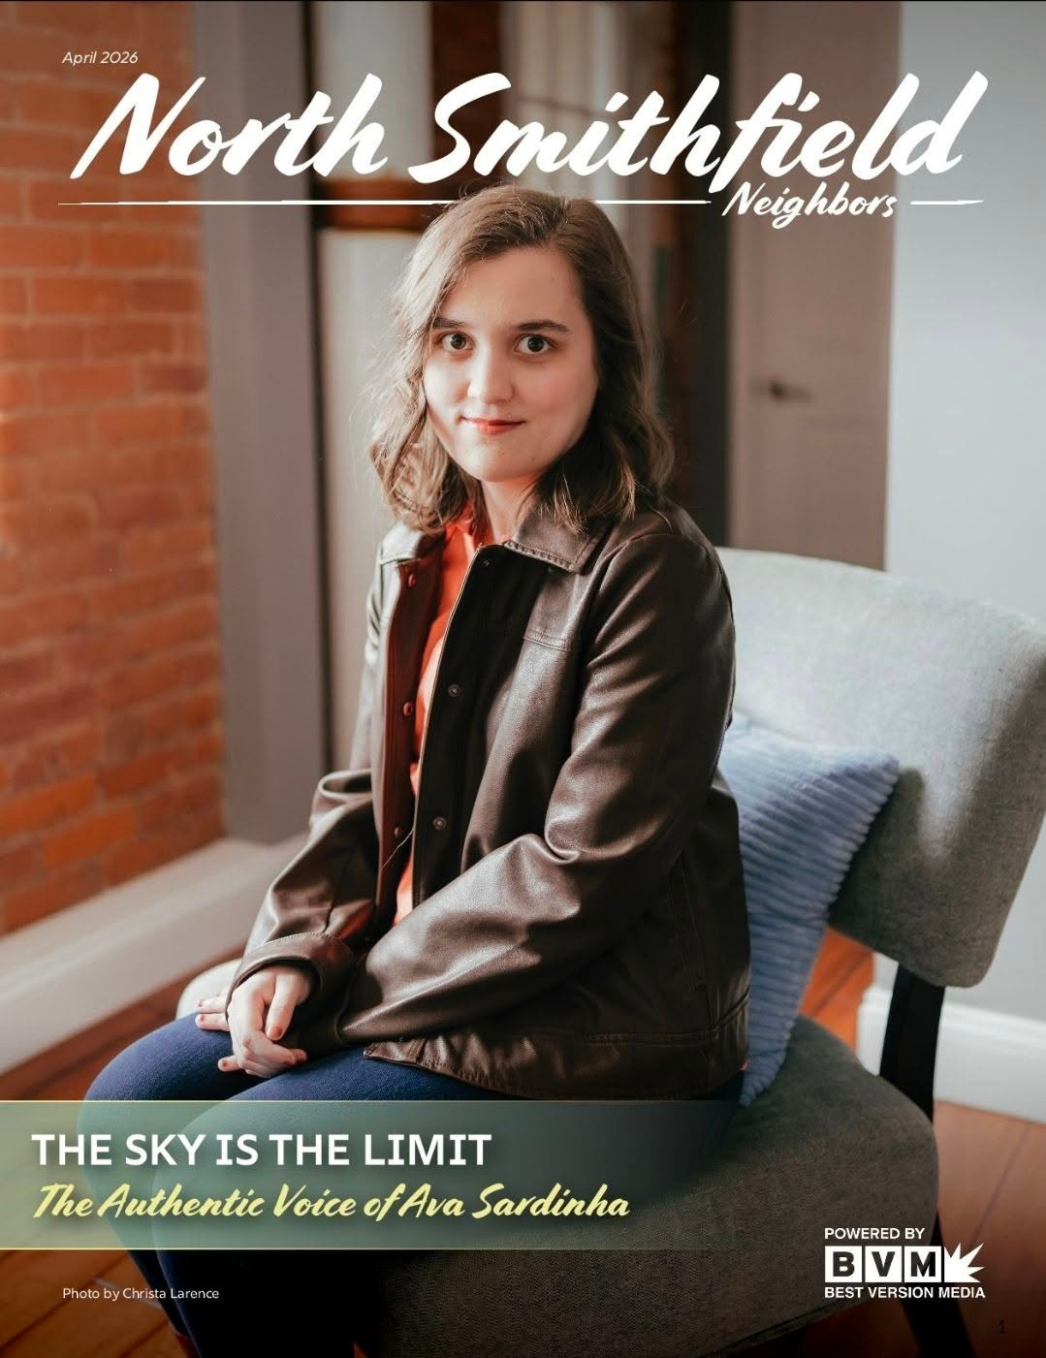 | Please join us in thanking and celebrating our Audio Journal volunteer Ava Sardinha!  Ava records and broadcasts the Audio Journal Show A Positive Outlook. Aired on the first, third, and fifth Thursdays each month, this program focuses on positive and uplifting news stories.  Ava was the winner of Audio Journal’s Voice of the People Award last year.  She was also recently featured in North Smithfield’s Neighbors publication, sharing more about her story and voice talents.  Thanks, Ava!
Read Ava’s Feature

Radio Active Theatre
Radio-Active Theatre brings the world of theater to our listeners. Stories are selected from Old Time Radio, Drama, Comedy, and original scripts written by Audio Journal volunteers. We’ve been active this summer with some exciting new episodes, with more coming soon.
Recent Shows  - Baggage is a comedy about two travelers, Phyllis and Bradley, who accidentally get the wrong bags at the airport and meet to exchange them. The play addresses Phyllis and Bradley's chance for love despite their emotional baggage .  - Flemming, a comedy/mystery about a bored businessman who decides to become a detective and the ridiculous situations that occur which imperil his friends and family. | In Production, Coming Soon!  - It Happened One Night, based on the famous film starring Clark Gable and Claudette Colbert, about a runaway heiress who spends time on the run with a newspaper reporter.  - A Visit to a Small Planet is about curious alien who lands in the backyard of a radio personality. He causes the earthlings to examine their civilization and human nature.
Listen to Radio Active Theatre

Take me out to the ball game!
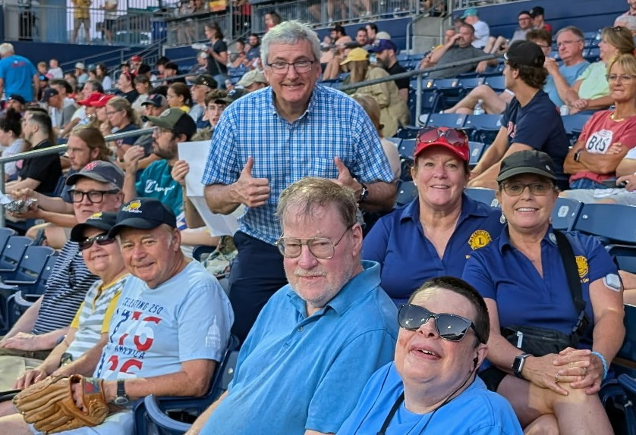

AJ Community Listeners, Baystate Council of the Blind members, & Worcester Lions recently attended the Eye Audio Radio: Eye Health Awareness WooSox game at Polar Park on Aug. 13th, 2026. Tickets were sponsored by Audio Journal.
In front row of picture from L to R: BSCB & AJ Listeners: Jim Murphy, Debbi Dymek, Jim Dymek, Mark Binnall, & Bill Ruggiero. In back row of picture from L to R: Worcester Lions, Harry Duchesne (AJ Exec. Dir.), Kristen Keane, & Keri Keane. Not pictured: Kathy and Sai Pitman.
A good time was had by all as The WooSox won the game 10-3 and Eye Health Awareness was celebrated.

Upcoming Programs: Speaking Volumes
Speaking Volumes, Audio Journal’s premiere LIVE Book Club, happens the first Tuesday of every month at 6:00PM. Here are the programs coming up this fall:
- September 1st: The Bluest Eye by Toni Morrison
- October 6th: Culpability by Bruce Holsinger
- November 3rd: A Marriage at Sea: A True Story of Love, Obsession and Shipwreck by Sophie Elmhirst
- December 1st: Rosarita by Anita Desai
Listen to Speaking Volumes

Coming this Fall 2026
The Memorial Foundation for the Blind (MFB) Accessibility Tech Show – A new collaboration between the Massachusetts Association for the Blind and Audio Journal (both Sponsored by MFB) – Day & Time TBD.
For more information, please email us at info@audiojournal.org or call our office at 508-797-1117
